1) Regional Level Webinar on “Re-Configuring the Mind-Post Covid-19 Consciousness” was conducted on 2nd July 2020. Dr.A.S..POOVAMMA, Principal Welcomed the Participants. Smt.D.M.Lathakumari Superintendent, Cauvery College Virajpet was the Resource person. More than 60 participants participated in this Webinar.

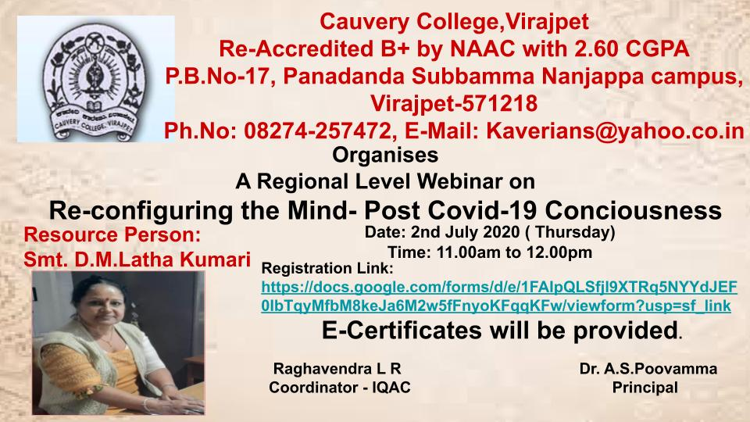

2) One day National Level Webinar on :Covid -19 pandemic :- Impact and strategies for Rural Degree Colleges in India” was organised on 9th July 2020, Dr.A.S..POOVAMMA, Principal Welcomed the Participants. Mr. K.G.Uthappa Secretary Cauvery Education Society (R) Gonikoppal presided over the webinar and Prof K.V.PRBHAKARA, Director of GSSS Simha Subbamahalakshi First Grade College Mysore was the Resource person. Nearly 475 participants Participated in this Webinar.

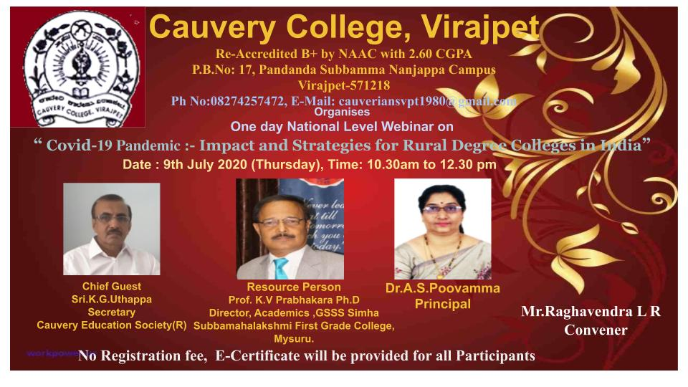

3) One Day National Level Webinar on “The Impact of Covid -19 on Higher Education” is being organised by IQAC and Department of Commerce and Management on 18th August 2020. Dr.A.S..POOVAMMA, Principal Will Welcome the dignitaries and participants. Dr.Anitha H.S is the Resources and Dr. P.Subrahmanya Yadapadithaya Vice Chancellor, Mangalore University will render the Keynote address and Prof.I.K.BIDDAPPA will preside over the Webinar.

